Day 4 – 20 Mar 2024

Spring Framework or Adv Spring Framework

40 hours training

Spring boot, Spring reactive modules, spring web client, spring with hibernate.

Spring transaction management, spring security etc.

<https://start.spring.io/>

springboot-with-jpa-data

starter --🡪 Web

starer 🡪 thymeleaf view

starter 🡪 jdbc for database connection

starter -🡪 jpa provide orm features

dependencies -🡪 mysql connector

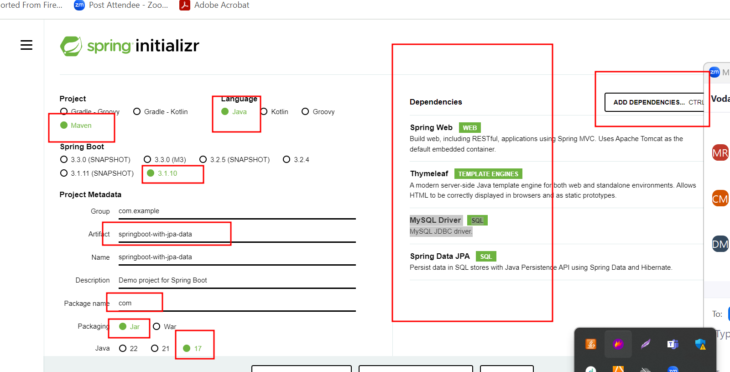

application.properties file contains all resources details.

Like server port number

Security

Database related file. : dispathcher-servlet.xml

Spring with database

1. Data source
2. JdbcTemplate
3. ORM Hibernate or JPA
4. Spring JPA Data: it is a spring module which provide abstract dao layer.

CrudRepository : core interface or super interface

JPARepository : sub interface provide JPA implementation

This interface base upon java 8.

By default @controller, @service, @repository annotation are disable.